**2020학년도 2학기 데이터베이스 설계 및 구축 최종 보고서**

**(야구 일정 관리)의 데이터베이스**

**설계 및 구축**

 

|  |  |
| --- | --- |
| **학 과** | **컴퓨터정보** |
| **분 반** | **3 반** |
| **과목명** | **데이터베이스** |
| **학 번** | **202032291** |
| **이 름** | **김강현** |
| **담당교수** | **김 경 민** |
| **제 출 일** | **2020년 12월 일** |



**목 차**

1. 프로젝트 개요 ···························································································································· 3

2. 요구사항 분석 ··························································································································· 4

3. 개념적 데이터 모델 ················································································································ 5

4. 논리적 데이터 모델 ················································································································ 6

5. 용어 사전 정의 ·························································································································· 7

6. 물리적 데이터 모델 ················································································································ 8

7. Table 기술서 ······························································································································ 10

8. SQL문 사용하기

1) 기본 SQL ···························································································································· 13

2) JOIN ······································································································································ 16

3) Sub Query ·························································································································· 19

9. 별첨(프로젝트 후기, Databace 구축 Dump 자료) ················································· 21

# 1. 프로젝트 개요

|  |  |
| --- | --- |
| 프로젝트 개요 | |
| **프로젝트 명** | **야구 일정 관리** |
| 1. 주제 선정 이유   주제는 야구 일정 관리로, 야구에 관심을 가지고 있어서 선정했다.   1. 주제 설명   주제는 야구 일정을 관리하는 시스템이다.  3. 기대 효과  기대 효과 야구 일정을 사용자들이 볼 수 있게 함으로써 경기 예매에 도움이 되게 하는 것이 기대 효과이다. | |

# 2. 요구사항 분석

|  |  |
| --- | --- |
| 요구사항 분석 | |
| **프로젝트 명** | **야구 일정 관리** |
| < 저장할 정보들 >   * 야구 일정표는 시간, 구장장소, 날짜, 팀1,팀2, 일정 번호를 가진다. * 구단은 연락처, 연고지, 구단명, 구단 번호를 가진다. * 관리자는 연락처, 이름, 관리자 번호, 비밀번호를 가진다.   < 제공할 기능들 >   * 야구 일정표는 날짜 및 구장장소 등을 검색할 수 있다. * 야구 일정표를 특정 일정 번호 이하 까지 볼 수 있다. * 야구 일정표에서 특정 장소만 추려 낼 수 있다. * 야구 일정표에서 특정 날짜를 기준으로 정렬해서 데이터를 볼 수 있다. * 관리자의 비밀 번호가 조건에 해당하는 경우에 관리자의 정보를 볼 수 있다. | |

# 3. 개념적 데이터 모델

|  |  |
| --- | --- |
| 개념적 데이터 모델 | |
| **프로젝트 명** | **야구 일정 관리** |

야구 일정표

구단

관리자

# 4. 논리적 데이터 모델

|  |  |
| --- | --- |
| 논리적 데이터 모델(ERD) | |
| **프로젝트 명** | **야구 일정 관리** |

관리자

구단

야구 일정표

일정 번호

날짜

팀1

팀2

구장 장소

시간

구단 명

구단 번호

연락처

연고지

관리자 번호

이름

연락처

비밀번호

구단 릴레이션

|  |  |  |  |
| --- | --- | --- | --- |
| 구단 명(PK) | 구단번호 | 연락처 | 연고지 |

야구 일정표 릴레이션

|  |  |  |  |  |  |
| --- | --- | --- | --- | --- | --- |
| 일정번호(PK) | 날짜 | 팀1 (FK) | 팀2 (FK) | 구장장소 | 시간 |

관리자 릴레이션

|  |  |  |  |
| --- | --- | --- | --- |
| 관리자번호(PK) | 이름 | 연락처 | 비밀번호 |

# 5. 용어 사전 정의

|  |  |  |  |
| --- | --- | --- | --- |
| 용어 사전 | | | |
| **프로젝트 명** | **야구 일정 관리** | | |
| **논리명** | **물리명** | **약어** | **설 명** |
| 구단번호 | TeamNumber | Tnumber | 구단 번호 |
| 구단 명 | TeamName | Tname | 구단 연락처 |
| 연락처 | Tel |  | 구단 명 |
| 연고지 | Home |  |  |
| 일정번호 | Datenumber | Dnumber | 일정 번호 |
| 날짜 | Date1 |  |  |
| 팀1 | Team1 |  |  |
| 팀2 | Tema2 |  |  |
| 구장 장소 | Place |  |  |
| 시간 | Time1 |  |  |
| 관리자 번호 | ManageNumber | Mnumber | 관리자 번호 |
| 이름 | Name |  |  |
| 연락처 | Tel |  |  |
| 비밀번호 | Password |  |  |
|  |  |  |  |
|  |  |  |  |
|  |  |  |  |
|  |  |  |  |
|  |  |  |  |
|  |  |  |  |
|  |  |  |  |
|  |  |  |  |
|  |  |  |  |
|  |  |  |  |
|  |  |  |  |

# 6. 물리적 데이터 모델

|  |  |
| --- | --- |
| 물리적 데이터 모델 | |
| **프로젝트 명** | **야구 일정 관리** |

Team relation

|  |  |  |  |
| --- | --- | --- | --- |
| Tname(PK) | tnumber | Tel | Home |

Schedule relation

|  |  |  |  |  |  |
| --- | --- | --- | --- | --- | --- |
| dnumber(PK) | Date1 | Team1(FK) | Team2(FK) | Place | Time1 |

Manager relation

|  |  |  |  |
| --- | --- | --- | --- |
| Mnumber(PK) | Name | Tel | password |

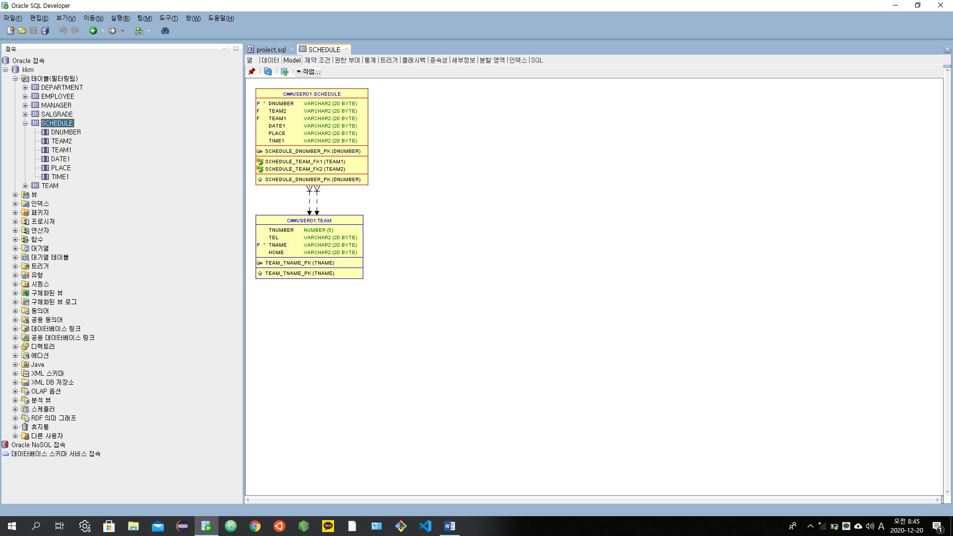

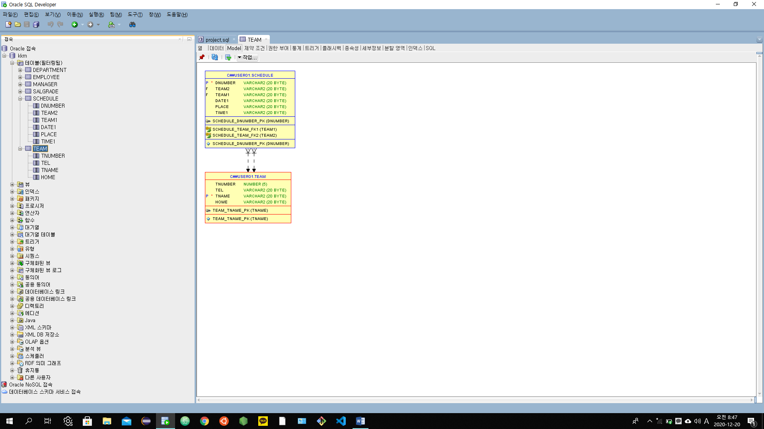

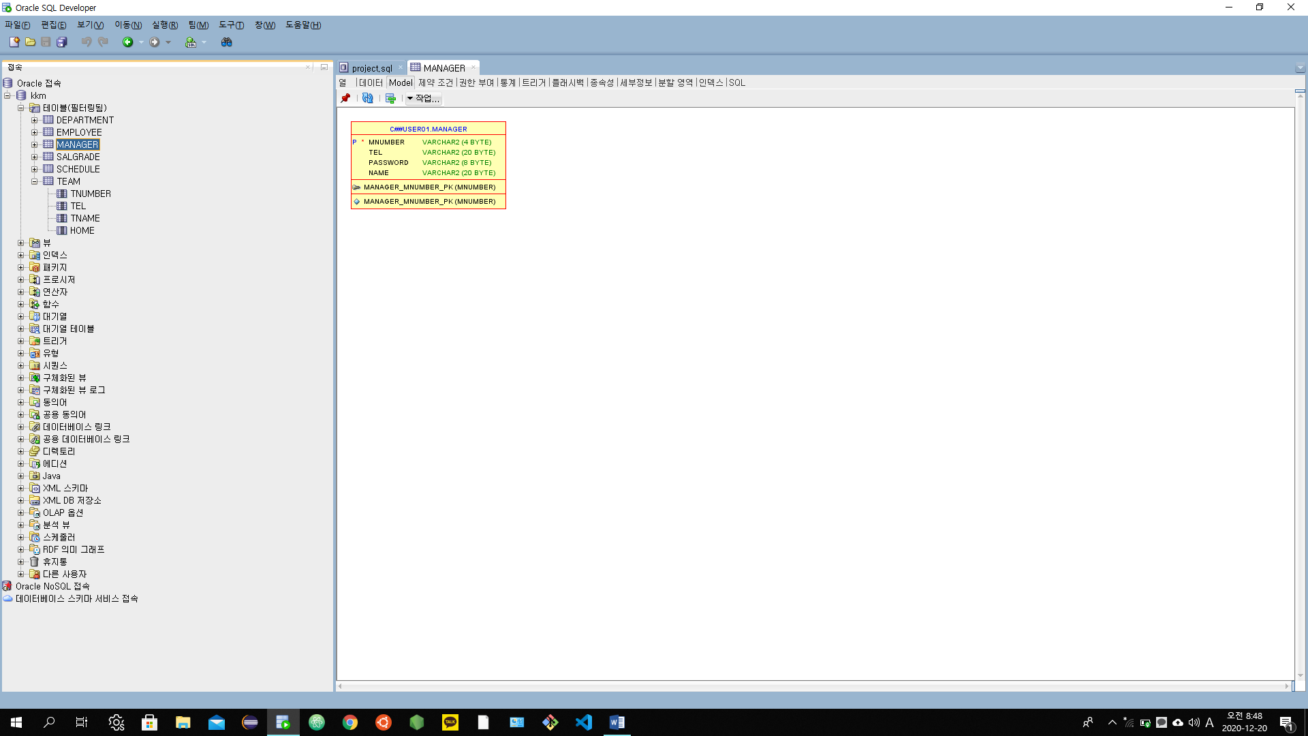

7. Table 기술서

|  |  |  |  |  |  |  |
| --- | --- | --- | --- | --- | --- | --- |
| Table 기술서 | | | | | | |
| **테이블 명** | | Team | | | | |
| **테이블 설명** | | 구단 테이블 | | | | |
| **No** | **Attribute** | **Data Type** | **NN** | **Ky** | **Default** | **Description** |
| 1 | Tname | varchar2(20) | Y | PK |  | 구단 명 |
| 2 | Tel | varchar2(20) |  |  |  | 연락처 |
| 3 | Tnumber | Number(5) |  |  |  | 구단 번호 |
| 4 | Home | varchar2(20) |  |  |  | 연고지 |
| 5 |  |  |  |  |  |  |
| 6 |  |  |  |  |  |  |
| 7 |  |  |  |  |  |  |
| 8 |  |  |  |  |  |  |
| 9 |  |  |  |  |  |  |
| 10 |  |  |  |  |  |  |
| 11 |  |  |  |  |  |  |
| 12 |  |  |  |  |  |  |
| 13 |  |  |  |  |  |  |
| 14 |  |  |  |  |  |  |
| 15 |  |  |  |  |  |  |
| **비 고** | | | | | | |
|  | | | | | | |

|  |  |  |  |  |  |  |
| --- | --- | --- | --- | --- | --- | --- |
| Table 기술서 | | | | | | |
| **테이블 명** | | MANAGER | | | | |
| **테이블 설명** | | 관리자 테이블 | | | | |
| **No** | **Attribute** | **Data Type** | **NN** | **Ky** | **Default** | **Description** |
| 1 | Mnumber | VARCHR2(4) | Y | PK |  | 관리자 번호 |
| 2 | Tel | VARCHR2(20) |  |  |  | 연락처 |
| 3 | Password | VARCHR2(8) |  |  |  | 비밀번호 |
| 4 | Name | VARCHR2(20) |  |  |  | 이름 |
| 5 |  |  |  |  |  |  |
| 6 |  |  |  |  |  |  |
| 7 |  |  |  |  |  |  |
| 8 |  |  |  |  |  |  |
| 9 |  |  |  |  |  |  |
| 10 |  |  |  |  |  |  |
| 11 |  |  |  |  |  |  |
| 12 |  |  |  |  |  |  |
| 13 |  |  |  |  |  |  |
| 14 |  |  |  |  |  |  |
| 15 |  |  |  |  |  |  |
| **비 고** | | | | | | |
|  | | | | | | |

|  |  |  |  |  |  |  |
| --- | --- | --- | --- | --- | --- | --- |
| Table 기술서 | | | | | | |
| **테이블 명** | | schedule | | | | |
| **테이블 설명** | | 경기 일정 표 테이블 | | | | |
| **No** | **Attribute** | **Data Type** | **NN** | **Ky** | **Default** | **Description** |
| 1 | dnumber | VARCHR2(20) | Y | PK |  | 일정 번호 |
| 2 | Team2 | Number (20) |  | FK |  | 팀2 |
| 3 | Team1 | Number(20) |  | FK |  | 팀1 |
| 4 | Date1 | VARCHR2(20) |  |  |  | 날짜 |
| 5 | Place | VARCHR2(20) |  |  |  | 구장 장소 |
| 6 | Time1 | VARCHR2(20) |  |  |  | 시간 |
| 7 |  |  |  |  |  |  |
| 8 |  |  |  |  |  |  |
| 9 |  |  |  |  |  |  |
| 10 |  |  |  |  |  |  |
| 11 |  |  |  |  |  |  |
| 12 |  |  |  |  |  |  |
| 13 |  |  |  |  |  |  |
| 14 |  |  |  |  |  |  |
| 15 |  |  |  |  |  |  |
| **비 고** | | | | | | |
|  | | | | | | |

# 8. SQL문 사용하기

## **1) 기본 SQL(select, where, 그룹함수, group by, having, order by) - 기본 5개**

select name as 이름, tel as "전화 번호", password as "비밀 번호", mnumber as "관리자 번호"

from manager

where substr(mnumber,1,2) = '36'

or mnumber in (3333,3555,3888)

and tel not like '_1412_'

order by name desc ;

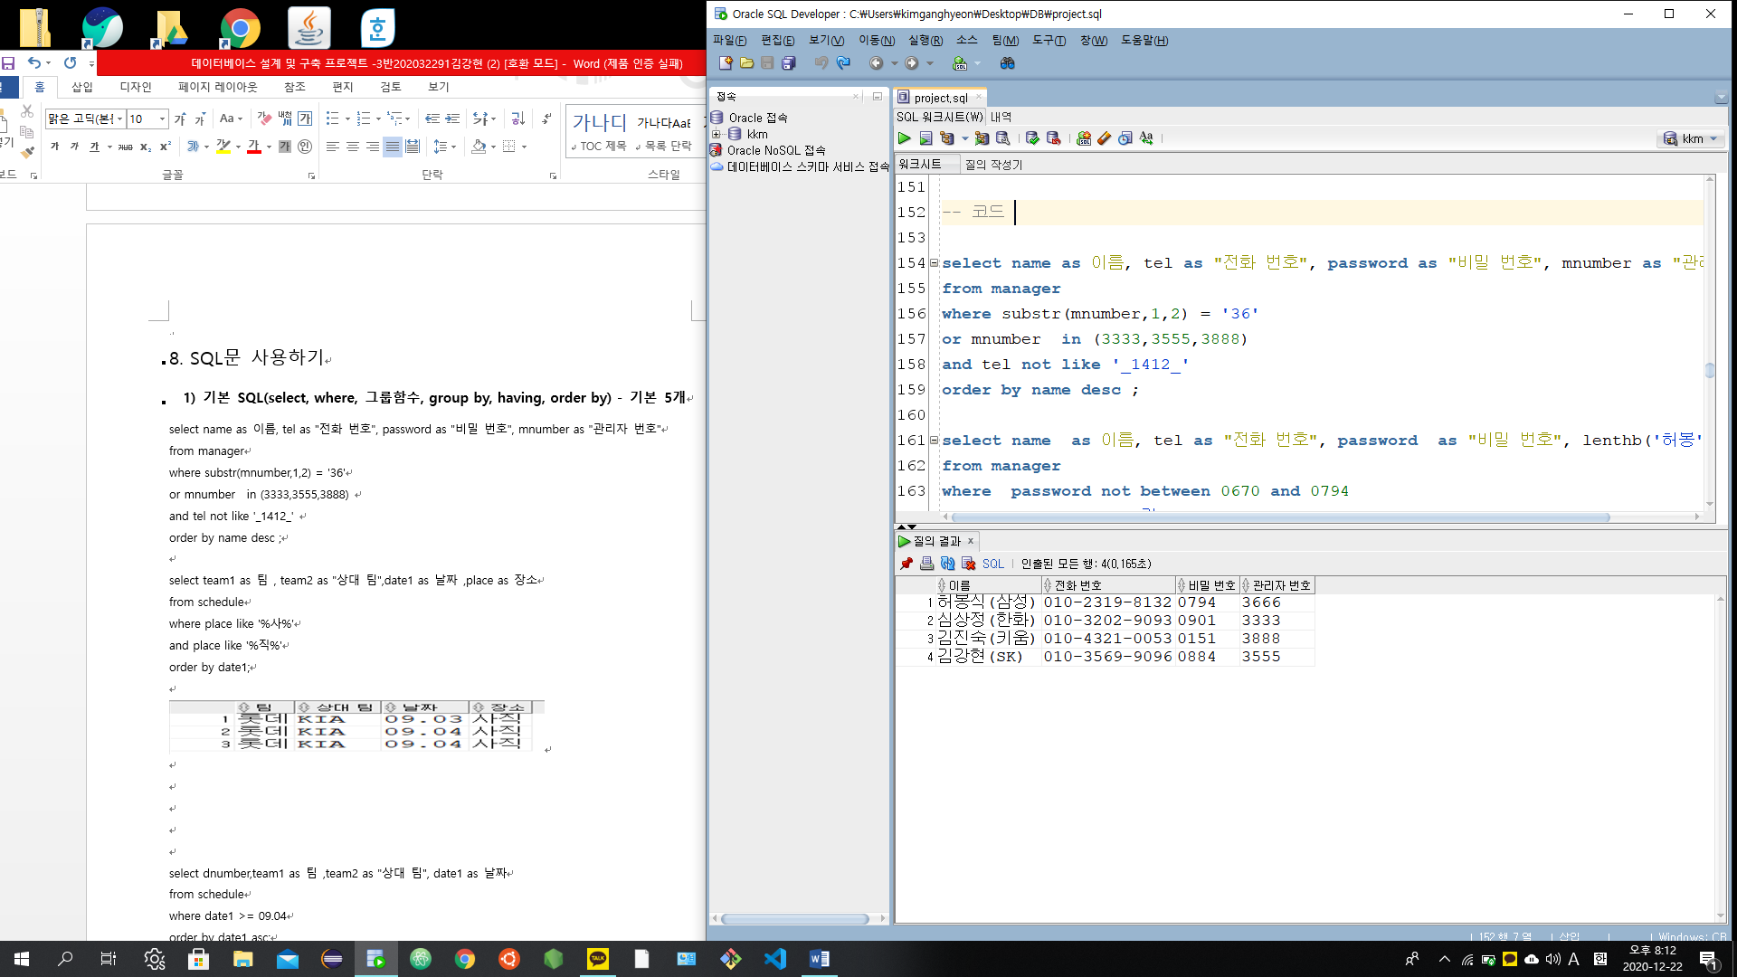

select name as 이름, tel as "전화 번호", password as "비밀 번호"

from manager

where password not between 0670 and 0794

and name not like '%김%'

or tel like '%32%'

order by password asc ;

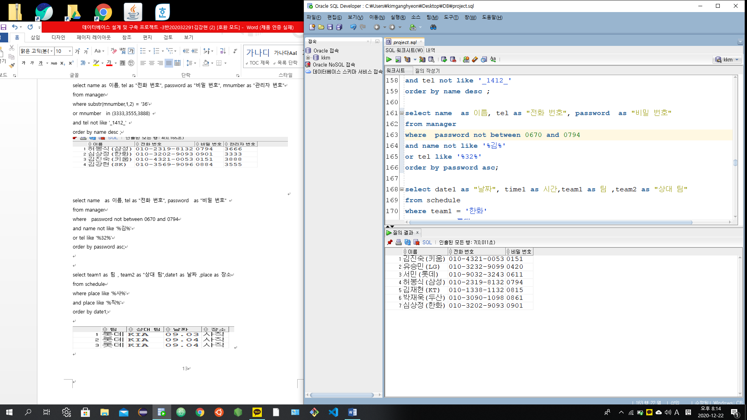

select date1 as "날짜", time1 as 시간,team1 as 팀 ,team2 as "상대 팀"

from schedule

where team1 = '한화'

or team2 = '롯데'

and date1 <= 09.03

order by date1 desc ;

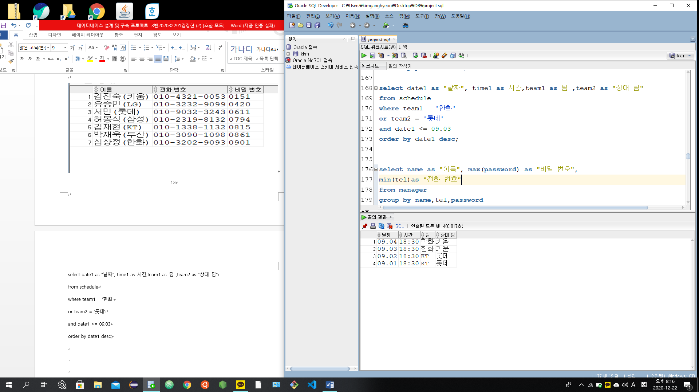

select name as "이름", max(password) as "비밀 번호",

min(tel)as "전화 번호"

from manager

group by name,tel,password

having max(password) >= 0861

order by name desc ;

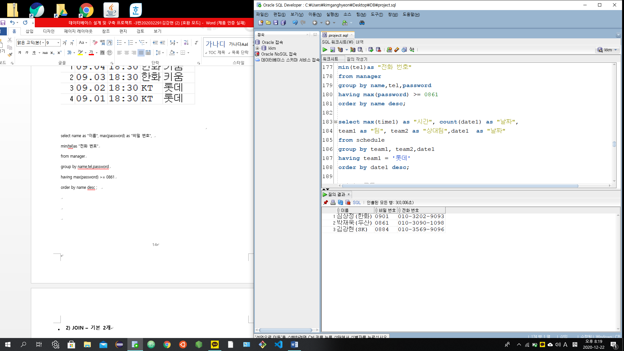

select max(time1) as "시간", count(date1) as "날짜",

team1 as "팀", team2 as "상대팀",date1 as "날짜"

from schedule

group by team1, team2,date1

having team1 = '롯데'

order by date1 desc ;

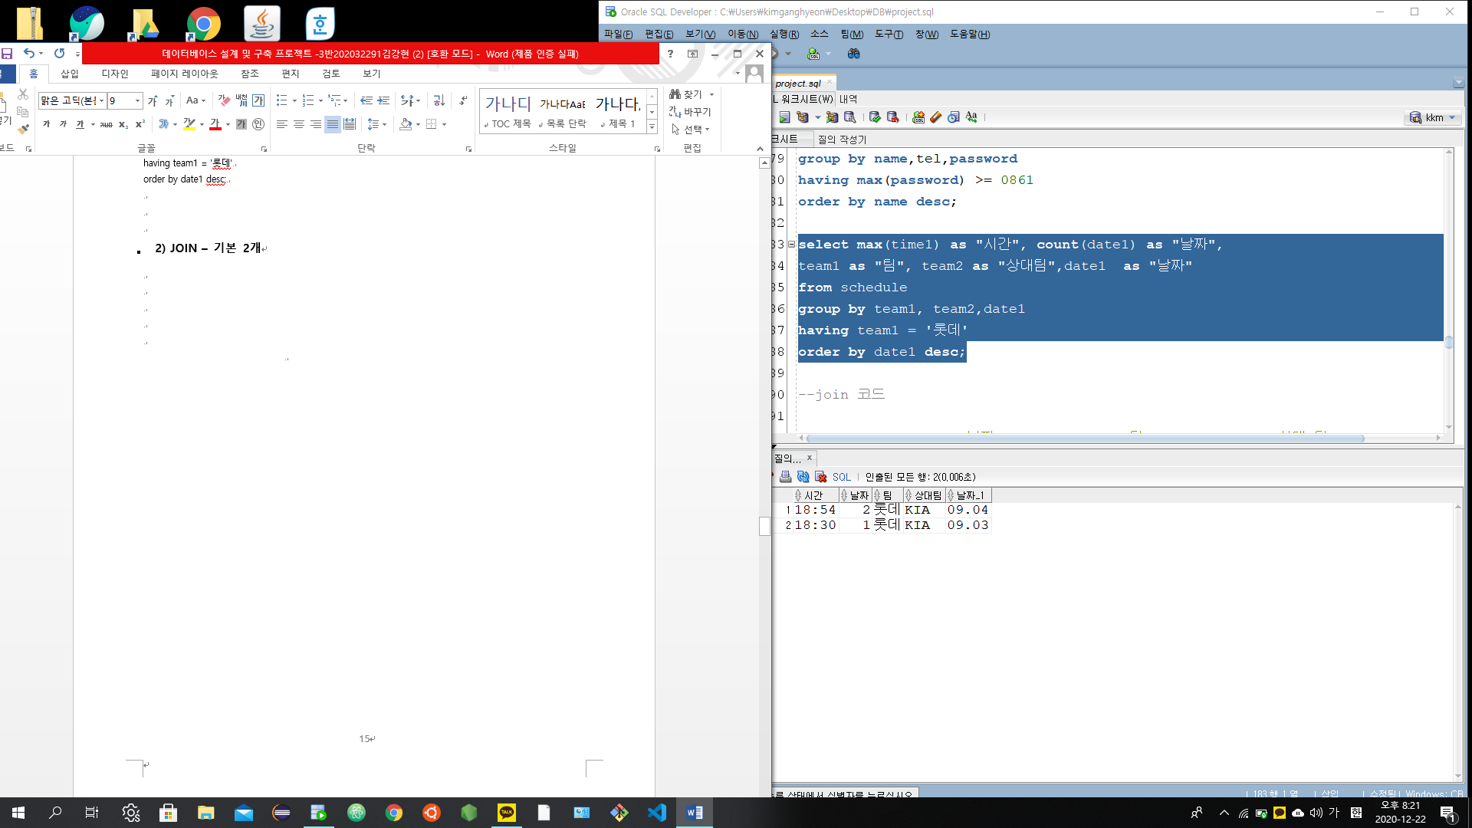

## **2) JOIN – 기본 2개**

select s.date1 as "날짜", s.team1 as "팀", s.team2 as "상대 팀"

,s.time1 as "시간",

t.tel as "전화 번호",t.home as "연고지"

from team t join schedule s

on t.tname = s.team2

where s.place = '잠실'

and s.team1 <> '한화'

or s.date1 like '%02%'

order by s.date1 asc ;

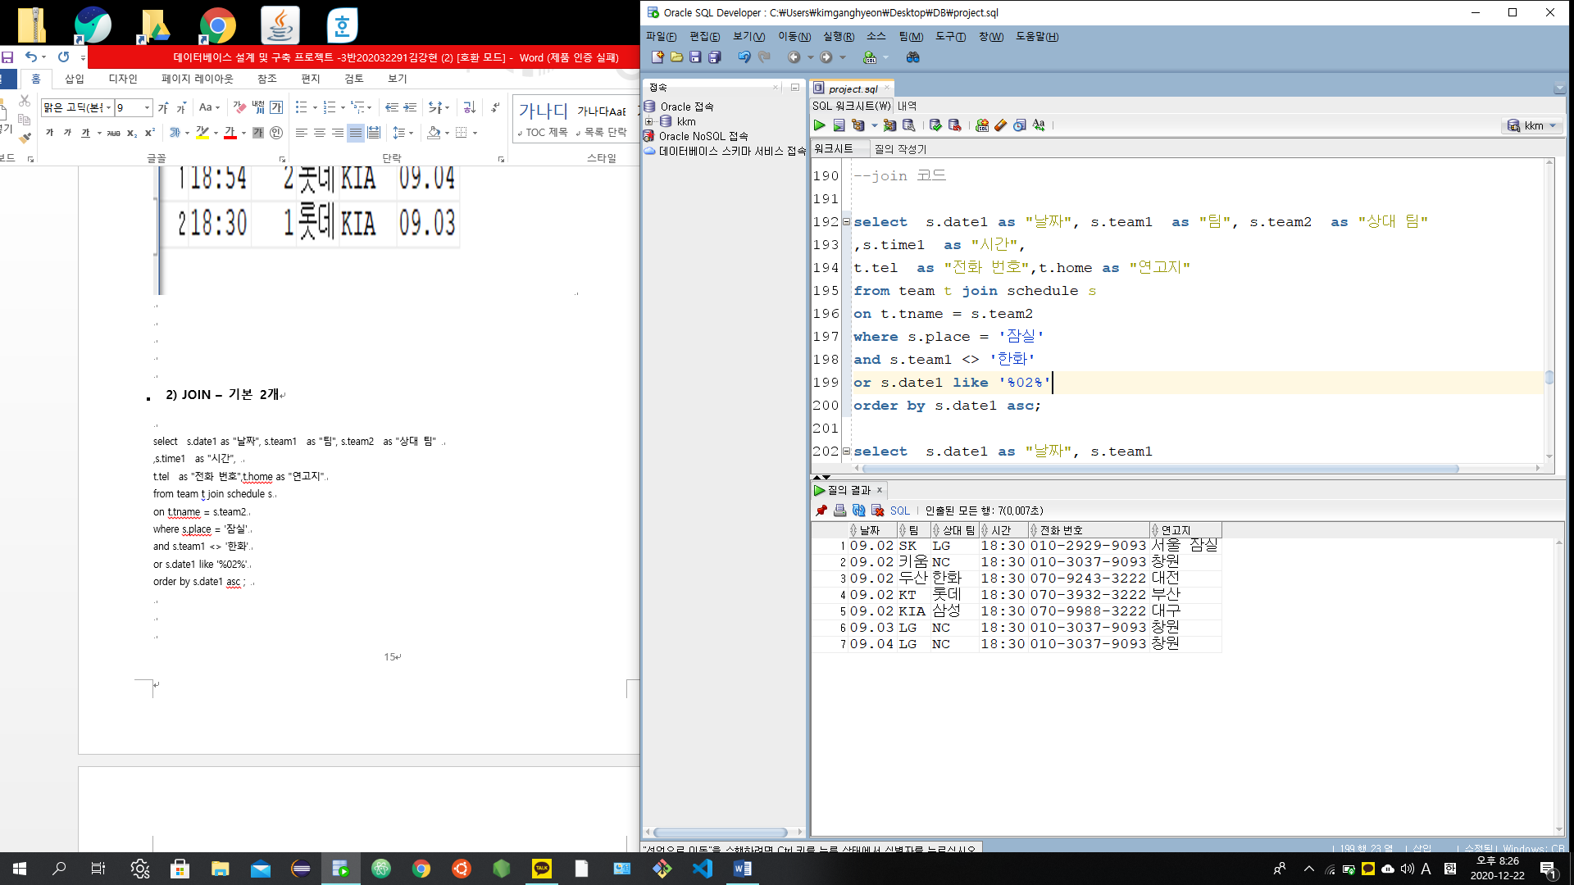

select s.date1 as "날짜", s.team1

as "팀", s.team2 as "상대 팀",s.time1 as "시간"

,t.tel, t.home, m.mnumber, m.password

from team t, schedule s, manager m

where t.tname = s.team1

and s.date1 = 09.03

and m.mnumber between 3222 and 3444

and m.password not in(0611,0420,0901)

order by time1 desc ;

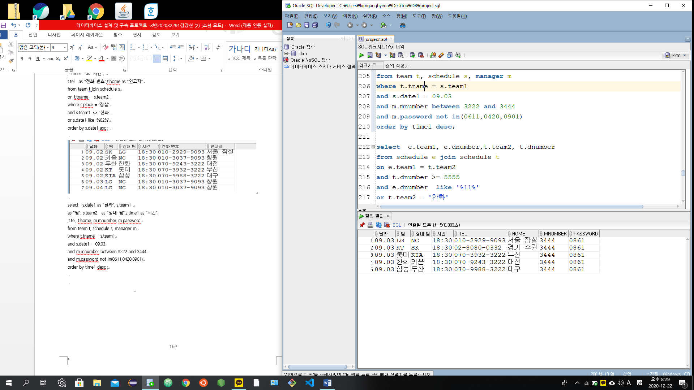

select e.team1 as "팀", e.dnumber as "일정 번호",e.date1 as "상대 팀 일정",

t.team2 as "상대 팀", t.dnumber as "상대 팀 일정 번호", t.date1 as "상대 팀 일정"

from schedule e join schedule t

on e.team1 = t.team2

or t.dnumber >= 5555

and e.dnumber like '%111%'

and e.team2 = '한화'

order by e.dnumber desc ;

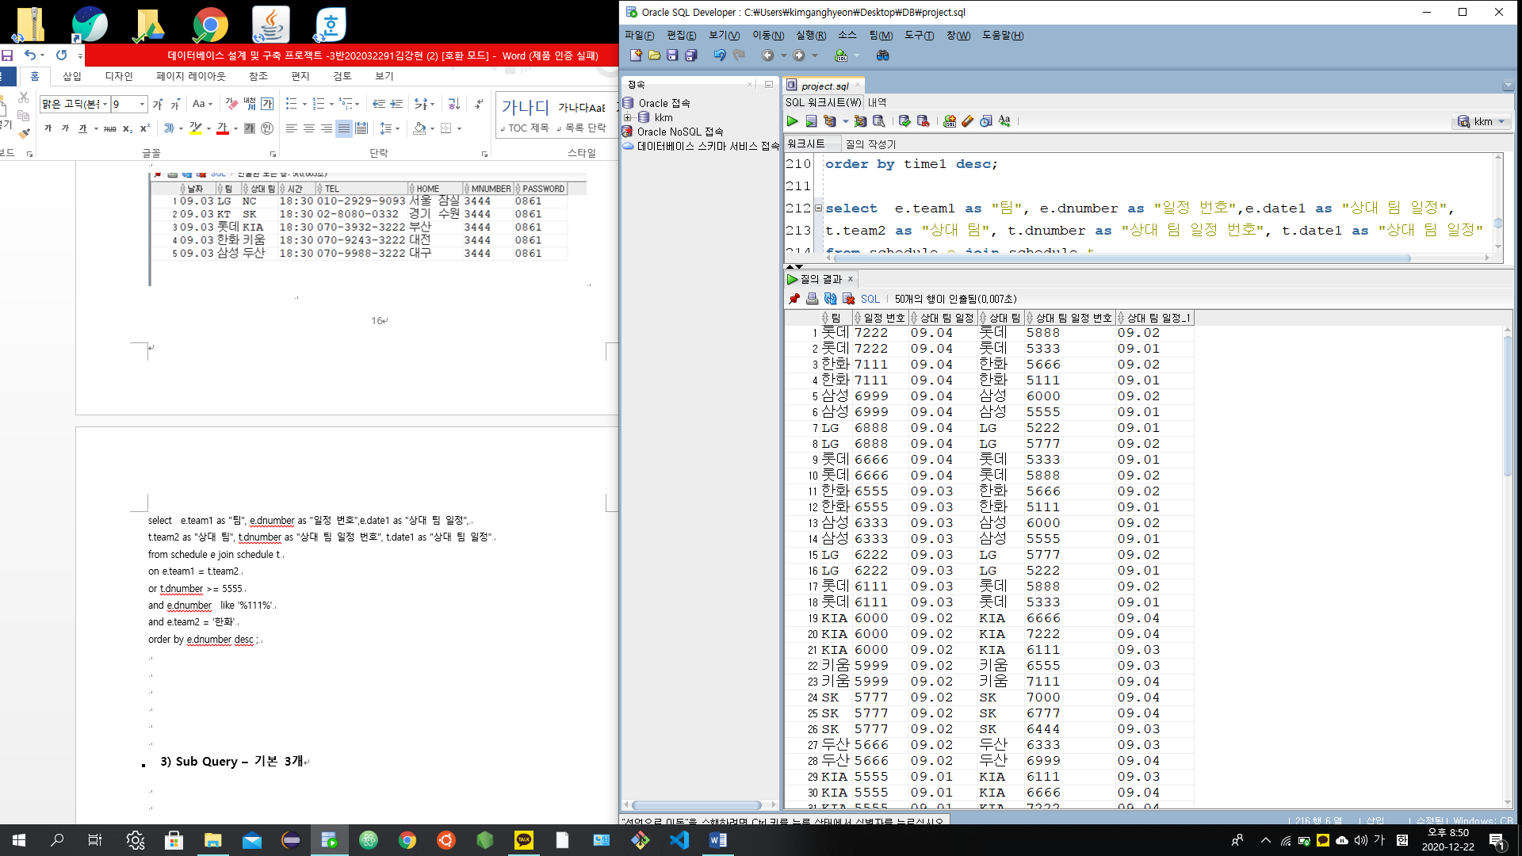

select e.team1 as "팀", e.dnumber as "일정 번호" ,e.date1 as "팀 일정",

t.team2 as "상대 팀", t.dnumber as "상대 팀 일정 번호" ,e.date1 as "상대 팀 일정"

from schedule e , schedule t

where e.team1 = t.team2

and e.dnumber <> 5555

and t.team2 = '두산'

order by e.dnumber desc;

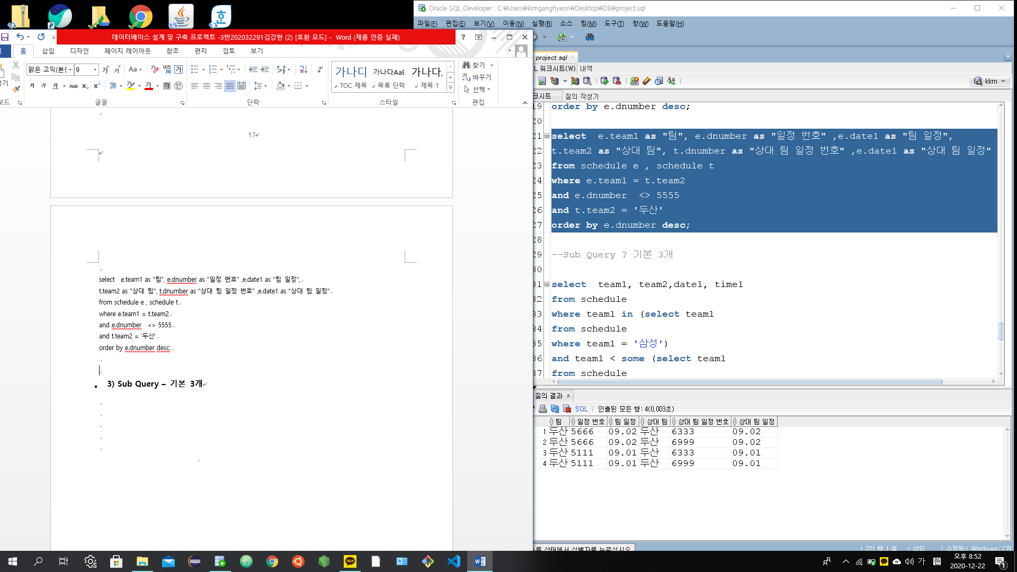

## **3) Sub Query – 기본 3개**

select team1, team2,date1, time1

from schedule

where team1 in (select team1

from schedule

where team1 = '삼성')

and team1 < some (select team1

from schedule

where date1 not like '%04%')

and team1 <> any (select team2

from schedule

where team2 = '한화')

order by team1 desc ;

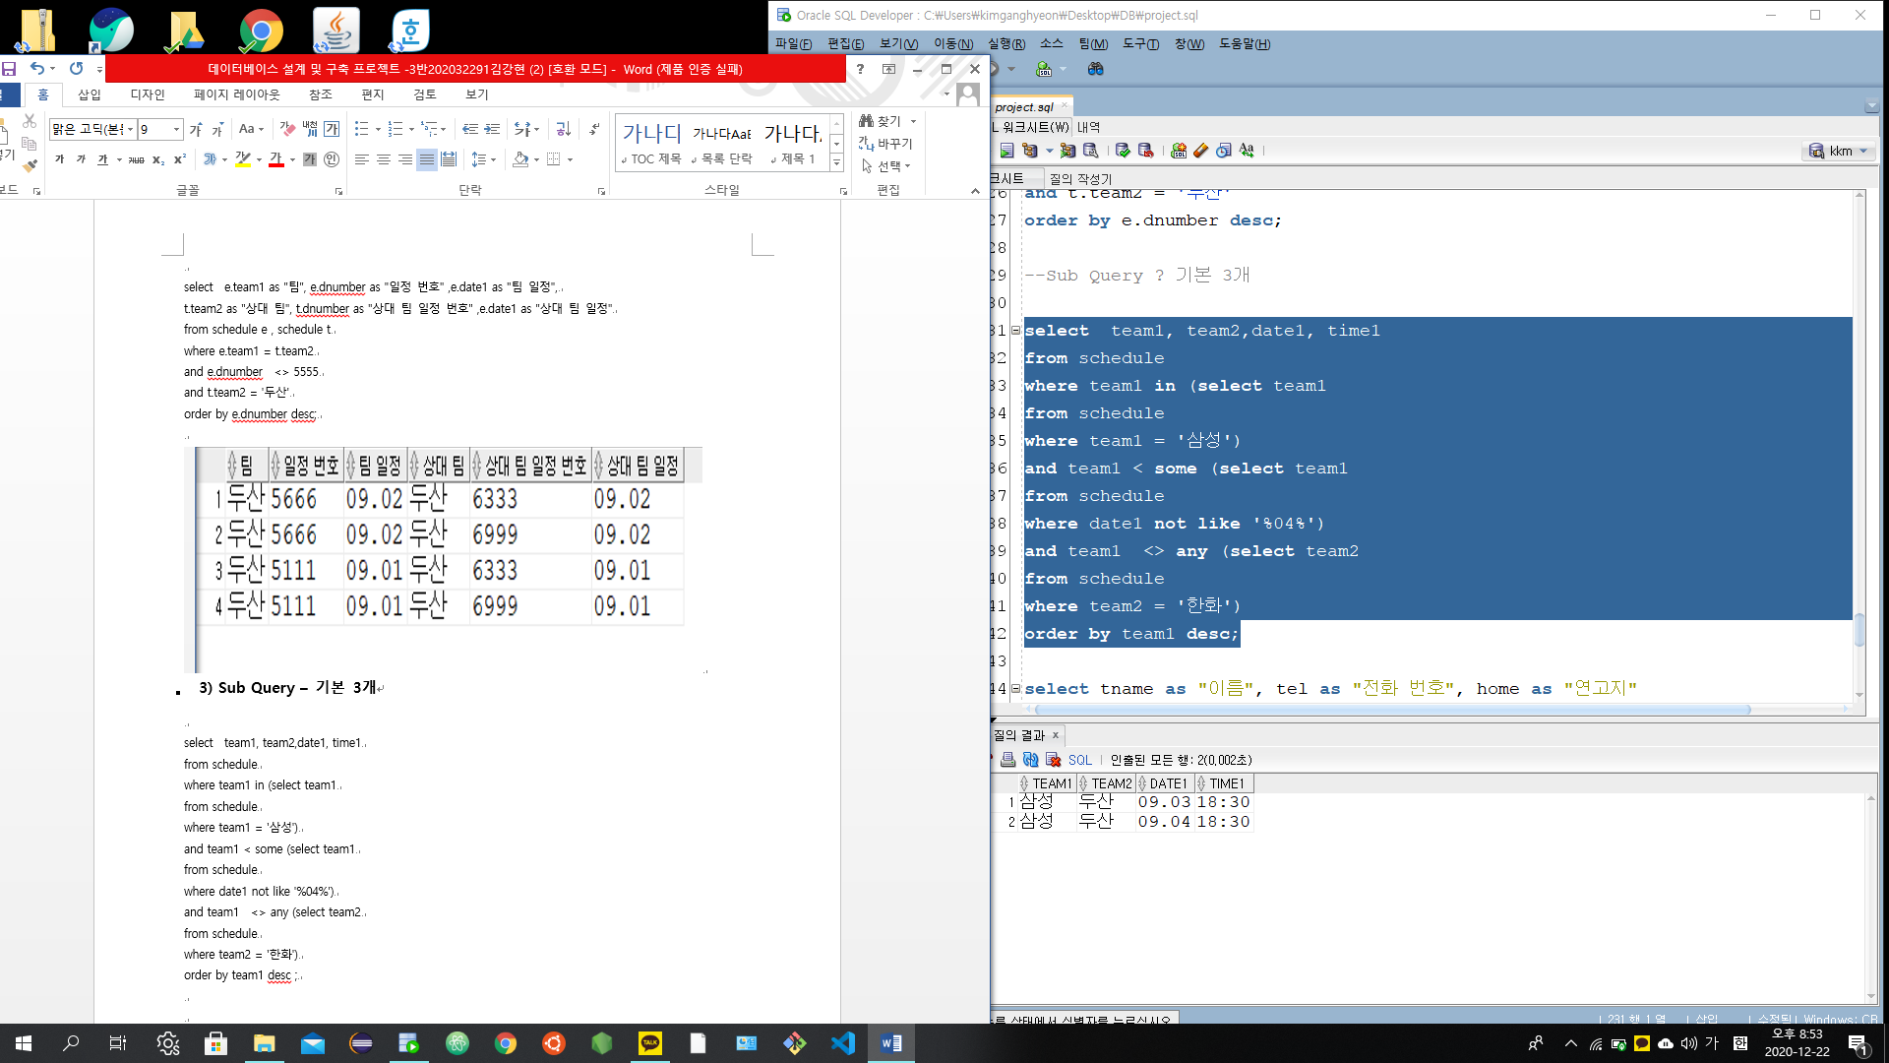

select tname as "이름", tel as "전화 번호", home as "연고지"

from team

group by tname, tel, home

having tname < all (select tname

from team

where tnumber >= 1777)

and tname >= some( select tname

from team

where tname <> 'NC')

and tname in (select tname

from team

where home like '%경기%')

order by tname asc ;

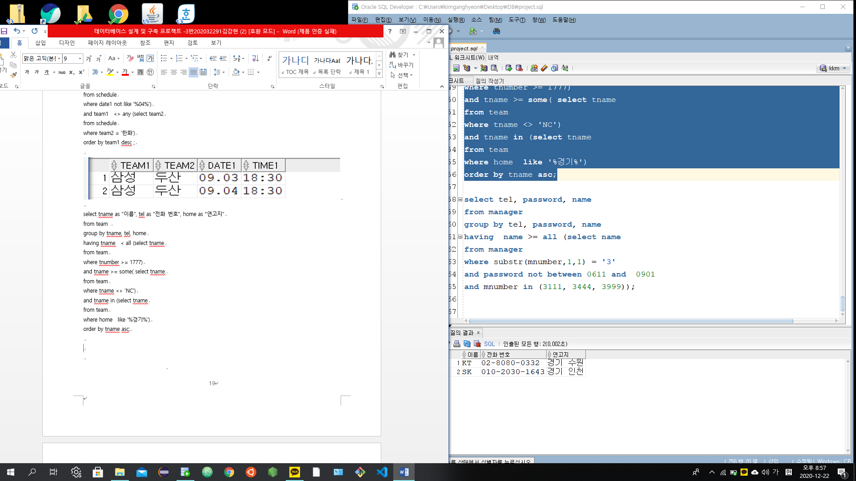

select tel as "전화 번호", password as "비밀 번호", name as "이름"

from manager

group by tel, password, name

having name >= all (select name

from manager

where substr(mnumber,1,1) = '3'

and password not between 0611 and 0901

and mnumber in (3111, 3444, 3999)) ;

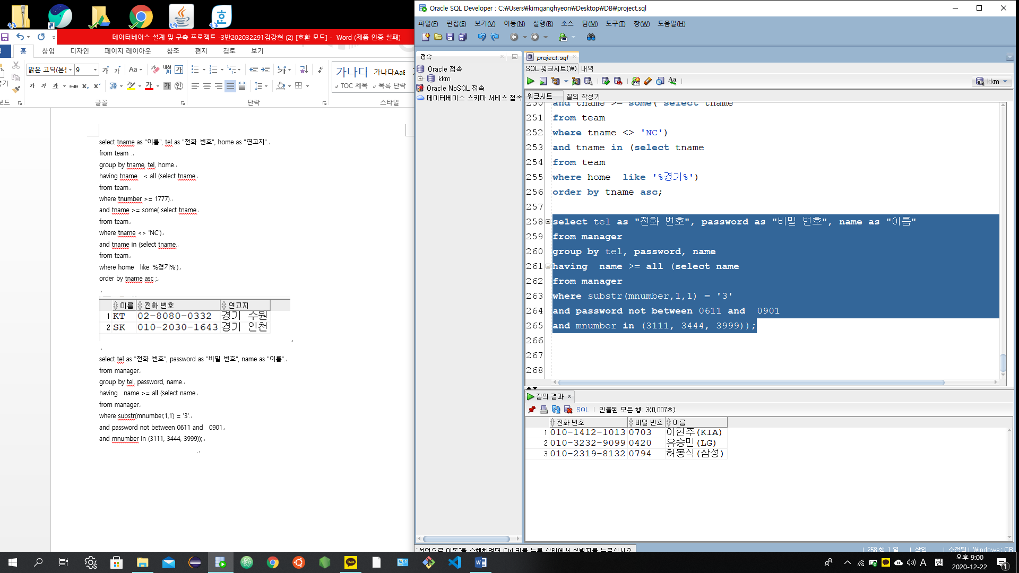

|  |
| --- |
| 별 첨 |

**별첨 1. 프로젝트 후기**

**별첨 2. Database 구축 dump 자료**

**1. 프로젝트 후기**

코드를 작성하고 오류를 해결하기가 힘들었다. FOREIN KEY를 데이터 지정하는데 애를 먹었고, FOREIN KEY를 해결하고 나니, 데이터 입력이 안 됐다. 알고 보니 PRIMARY KEY와 FOREIN KEY의 자료 형이 달라서 입력이 안 된 것을 알고 대개 허탈해하기 했다. 그러나, 오류를 해결하고 나니 기쁘기도 했다. 이런 프로젝트를 또 다시 했으면 좋겠고, 프로젝트에 시간을 많은 시간을 투자한 것과 최종 보고서를 작성한 것에 대해서 후회하지 않으며, 감사하게 생각한다. 또 이런 프로젝트가 다른 과목에도 있으면 그걸 기쁘게 생각하고, 엄청난 스트레스를 받으면서 그 프로젝트에도 많은 시간을 투자할 것 이다.

**2. Database 구축 dump 자료**

**< 계정 생성하기 >**

conn system/sys;  
  
create user c##user01 identified by user01  
default tablespace users  
temporary tablespace temp  
quota unlimited on users;  
  
grant connect to c##user01;  
grant resource to c##user01;  
  
conn c##user01/user01;  
  
show user;

**< 테이블 생성하기 >**

**create table Team(**

**tnumber number(5),**

**tel varchar2(20),**

**tname varchar2(20) constraint Team_tname_pk primary key,**

**Home varchar2(20));**

**create table schedule(**

**dnumber varchar2(20) constraint schedule_dnumber_pk primary key,**

**team2 varchar2(20),**

**team1 varchar2(20),**

**date1 varchar2(20),**

**place varchar2(20),**

**time1 varchar2(20),**

**constraint schedule_team_FK1 foreign key (team1) references Team(tname),**

**constraint schedule_team_FK2 foreign key (team2) references Team(tname));**

**create table manager(**

**mnumber varchar2(4) constraint manager_mnumber_pk primary key,**

**tel varchar2(20),**

**password varchar2(8),**

**name varchar2(20));**

**< 테이블 데이터 추가하기 >**

1.테이블 Team

insert into Team

values (1000, '010-3037-9093', 'NC', '창원');

insert into Team

values (1111, '010-2929-9093', 'LG','서울 잠실');

insert into Team

values (1222, '010-2030-1643', 'SK','경기 인천');

insert into Team

values (1333, '02-8080-0332', 'KT','경기 수원');

insert into Team

values (1444, '02-3636-8993', 'KIA','전남광주');

insert into Team

values (1555, '02-1232-2131', '두산','서울 잠실');

insert into Team

values (1666, '070-3203-3222', '키움','서울 고척');

insert into Team

values (1777, '070-9988-3222', '삼성','대구');

insert into Team

values (1888, '070-9243-3222', '한화','대전');

insert into Team

values (1999, '070-3932-3222', '롯데','부산');

2.테이블 manager

insert into manager

values (3222, '010-9032-3243', '0611','서민(롯데)');

insert into manager

values (3111, '010-3232-9099', '0420','유승민(LG)');

insert into manager

values (3333, '010-3202-9093', '0901','심상정(한화)');

insert into manager

values (3444, '010-3090-1098', '0861','박재욱(두산)');

insert into manager

values (3555, '010-3569-9096', '0884','김강현(SK)');

insert into manager

values (3666, '010-2319-8132', '0794','허봉식(삼성)');

insert into manager

values (3777, '010-1025-8123', '0670','김경민(NC)');

insert into manager

values (3888, '010-4321-0053', '0151','김진숙(키움)');

insert into manager

values (3999, '010-1338-1132', '0815','김재현(KT)');

insert into manager

values (3100, '010-1412-1013', '0703','이현주(KIA)');

3. 테이블 schedule

insert into schedule

values ( 5111,'한화', '두산','09.01','서울','18:30');

insert into schedule

values (5222, 'LG','SK','09.01','문학','18:30');

insert into schedule

values ( 5333,'롯데','KT','09.01','수원','18:30');

insert into schedule

values (5444, 'NC','키움','09.01','고척','18:30');

insert into schedule

values ( 5555,'삼성','KIA','09.01','광주','18:30');

insert into schedule

values (5666, '한화','두산','09.02','잠실','18:30');

insert into schedule

values (5777, 'LG','SK','09.02','문학','18:30');

insert into schedule

values (5888, '롯데','KT','09.02','수원','18:30');

insert into schedule

values (5999, 'NC','키움','09.02','고척','18:30');

insert into schedule

values (6000, '삼성','KIA','09.02','광주','18:30');

insert into schedule

values (6111, 'KIA','롯데','09.03','사직','18:30');

insert into schedule

values (6222, 'NC','LG','09.03','잠실','18:30');

insert into schedule

values (6333, '두산','삼성','09.03','대구','18:30');

insert into schedule

values (6444, 'SK','KT','09.03','수원','18:30');

insert into schedule

values (6555, '키움','한화','09.03','대전','18:30');

insert into schedule

values (6666, 'KIA','롯데','09.04','사직','15:00');

insert into schedule

values (6777, 'SK','KT','09.04','수원','15:00');

insert into schedule

values (6888, 'NC','LG','09.04','잠실','18:30');

insert into schedule

values (6999, '두산','삼성','09.04','대구','18:30');

insert into schedule

values (7000, 'SK','KT','09.04','수원','18:30');

insert into schedule

values (7111, '키움','한화','09.04','대전','18:30');

insert into schedule

values (7222, 'KIA','롯데','09.04','사직','18:54');